Gaddum Advocacy Feedback Form: Easy Read

- Do you know more about Advocacy now?
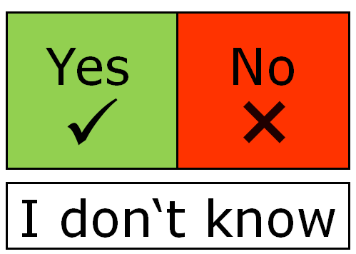

- Did your Advocate help you understand what was going on?

- Did your Advocate help you get your voice heard?

- Did your Advocate help you advocate for yourself?

- Did your Advocate help you get what you wanted?

- Were you happy with the service overall?

Gaddum Advocacy Feedback Form

Please tick the box if you agree with the following statements:

I understand my rights more

I felt satisfied whilst engaging in the process regardless of the outcome

I was able to make an informed choice that was right for me

I felt that my Advocate listened to me

I felt empowered

I feel more able to advocate for my friends, family or peers

For inpatients only: What outcomes were achieved? (Tick the box)

Treatment or care was changed per their request

Patient reports better mental health outcomes

Patient reports better physical health outcomes

Patient reports greater satisfaction in inpatient stay

Patient discharged

What could your Advocate have done better?

Please provide any other outcomes, comments or feedback here:

Your rights
As your Advocacy provider, we have the responsibility to listen to the people accessing our Advocacy service.
You have the right to feedback to us in any format you prefer. If you don’t want to fill in this form you can ask an Advocate to help you.
If you would rather provide us with feedback in another format, here is our contact information below:

Our Postal Address:
Gaddum Advocacy
c/o St Wilfrid’s Enterprise Centre
Royce Road
Hulme
Manchester
M15 5BJ

Our website:
Gaddum.org.uk
Our phone number:
0161 834 6069

Our email:
info@gaddum.org.uk

